Multiple-choice section – choose the correct answer

Question 1 [12.1]

Which of the following is a linear equation?

A  B y = x2 – 3x + 4 C  D 

Question 2 [12.1]

The equations of the horizontal asymptote and the vertical asymptote, respectively, of the rectangular hyperbola  are:

A y = -8, x = 6 B x = 6, y = -8 y = 5x – 5 C y = 6, x = -8 D x = -8, y = 6

Question 3 [12.1]

The radius and the coordinates of the centre of the circle (x + 6)2 + (y – 4) = 9, are:

A 9 and (-6, 4) B 3 and (-6, 4) C 9 and (6,-4) D 3 and (6, -4)

Question 4 [12.2]

The graph of  is:

A B C D

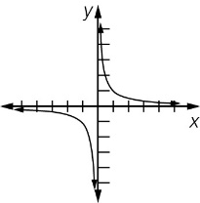 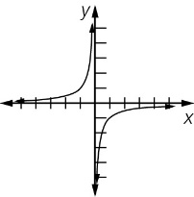 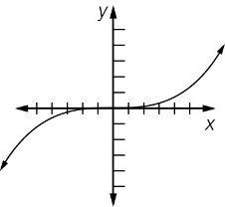 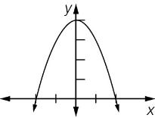

Question 5 [12.3]

Using index laws, this expression simplifies to:



A  B  C  D 

Question 6 [12.3]

Using index laws, this expression simplifies to:

 ÷ 

A  B a2b11 C  D a2b5

Question 7 [12.4] [10A]

Which expression is not equivalent to :

A  B  C  D 

Question 8 [12.6] [10A]

The value of  is:

A 0.5 B -3 C 2 D -2

Multiple-choice results: ___ / 8

Short answer section

Question 9 4 marks [12.1]

Choose from the following words to complete the sentences below.

base coefficient index irrational number power surd

In the term 5x6, x is the ________________, 5 is the ____________________ and 6 is the ________________ or __________________.

Question 10 6 marks [12.2]

Explain the transformations required to produce each of the following graphs.

(a) (x + 1)2 + (y – 1)2 = 9 from (x – 2)2 + (y + 3)2 = 25

(b) y =  – 3 from y = 4x

(c) y = + 3 from y = 

Question 11 10 marks [12.2]

(a) For the relationship between two variables x and y, as one variable increases, the other decreases. The graph of the relationship has a horizontal asymptote at 3 and a vertical asymptote at -1, where the graph is discontinuous.

(i) Based on this description, what type of graph is this?

(ii) Write an equation for this relationship.

(iii) Determine the value of the x-intercept for this relationship.

(iv) Determine the value of the y-intercept for this relationship.

(v) Sketch the relationship showing all relevant points.

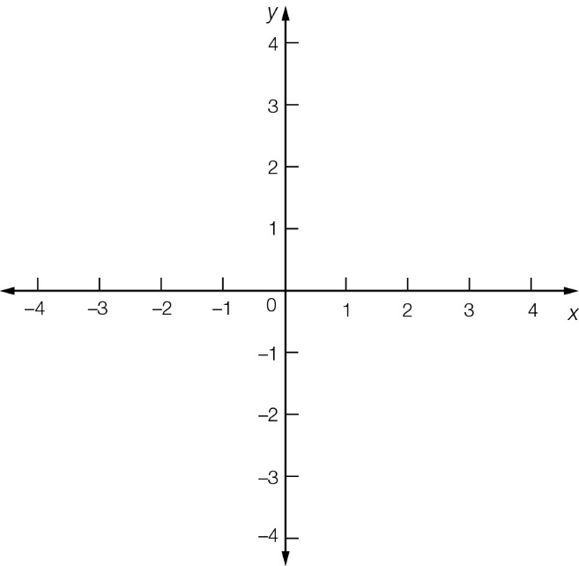

(b) The graph of another relationship between x and y continually increases as x increases, doubling at a constant rate, with a limiting value at y = 3.

(i) Based on this description, what type of graph is this?

(ii) Write an equation for this relationship.

(iii) Determine the value of the x-intercept for this relationship.

(iv) Determine the value of the y-intercept for this relationship.

(v) Sketch the relationship showing all relevant points.

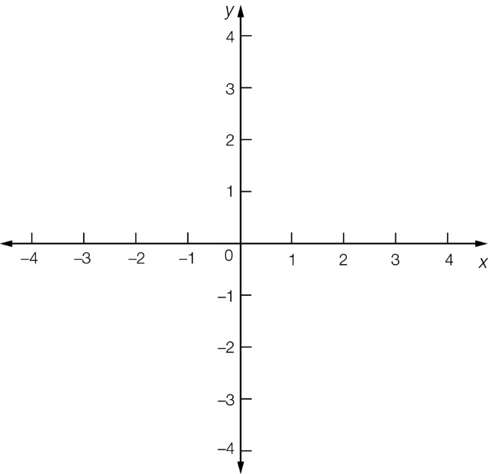

Question 12 1 mark [12.5] [10A]

Write the equivalent index statement.

(81) = 4__________________________

Question 13 6 mark [12.5] [10A]

Solve the following equations.

(a) (x) = 4

(b) (1000) = 3

(c) 2(x + 5) = 11

Question 14 4 mark [12.3]

Simplify the expression, writing your answer with positive indices.

 ÷ 

Question 15 3 mark [12.4] [10A]

Without using a calculator find the value of .

Question 16 3 mark [12.4] [10A]

Simplify the expression writing your answer using power notation.

4 × 5

Question 17 6 marks [12.6] [10A]

(a) Find x if (15 625) = 6.

(b) Find y if (15 625) = 12.

(c) Find z if logz (15 625) = 3.

Short answer results: ___ / 43

Extended answer section

Question 18 9 marks [12.2]

(a) Sketch the graphs of the circles described by these equations on the axes below.

A  B 

C  D 

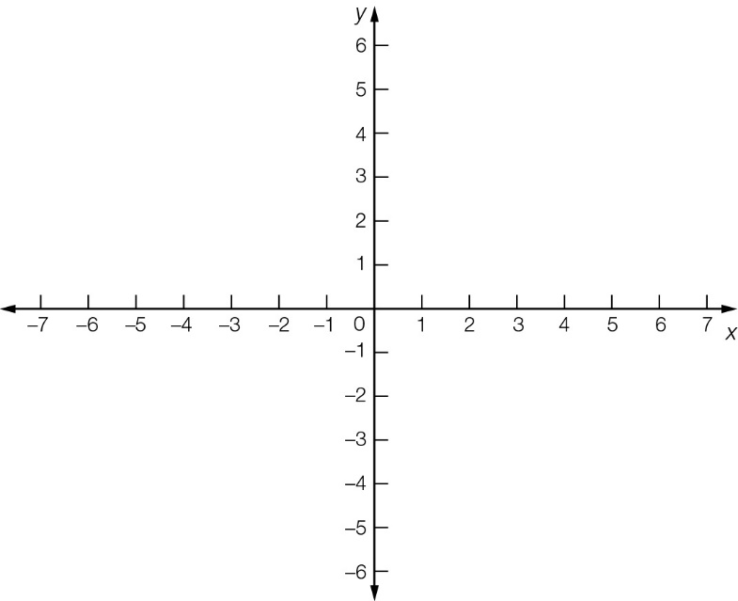

(b) On the same set of axes, sketch a circle with centre (-2, 5) and radius 1.

(c) Write the translations required to shift each circle to this position.

Question 19 6 marks [12.2]

The graph of the exponential equation y = 3(x + 2) + 1 is shown below.

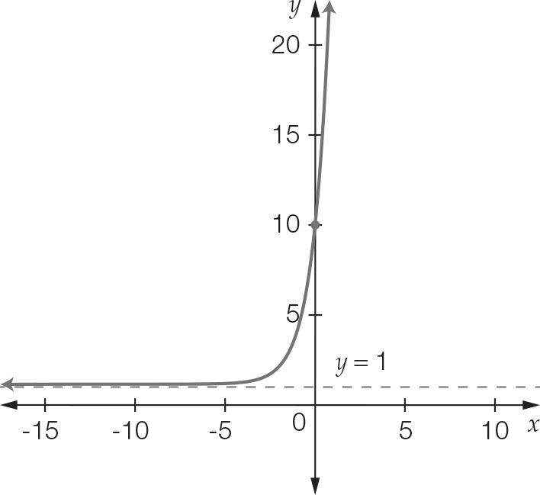

(a) State the values of a, h, and k for the general equation for an exponential y = a(x – h) + k.

(b) Does this graph have an asymptote. If so, state the value of the asymptote. If not, explain why.

(c) Confirm that the *y*-intercept is at (0, 10).

(d) What transformations are needed to obtain this graph from the graph with equation y = 3x?

Question 20 8 marks [12.2]

When heated, the temperature T °C of a bar of metal increases according to T = 3kt + 15, where t is the time in seconds.

(a) If the temperature is 24 °C after 10 seconds, what is the value of k?

(b) What was the initial temperature of the metal bar?

(c) Show that after 20 seconds the temperature of the metal will be 80 °C hotter than its initial temperature.

(d) Which three points can now be used to sketch the graph of T = 3kt + 15 for 0 ≥ t ≥ 20?

Question 21 6 marks [12.1, 12.2]

The equation of the rectangular hyperbola shown is of the form .

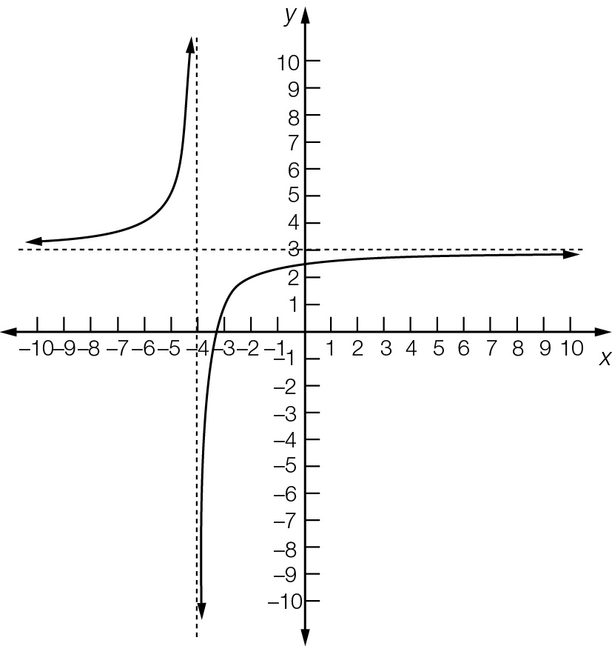

(a) State the values of h and k.

(b) If  where x = -2, find the value of a.

(c) Use your answer to part (a) and (b) to state the transformations needed to obtain the graph with equation from the graph of .

(d) State the transformations required so that intersection of the vertical asymptote with the horizontal asymptote is translated to the point (1, 5).

Extended answer results: ___ / 29

TOTAL test results: ___ / 80